Friends of the Lower Suwannee and Cedar Keys National Wildlife Refuges
Monthly Board Meeting Agenda
6/20/2023
https://ufl.zoom.us/j/92714749141

Approval Items
- Accept or modify the agenda
- Approve Minutes from previous Board Meeting
  - Draft in Dropbox
- Treasurer’s Report
  - Financial statements in Dropbox/email

Refuge Update
- Andrew

Discussion Items
- Fundraising
  - Need a lead person to research and apply for grants. Andrew sent a 4 page document of possible grant leads as a place to start. Money needed for Vista, Junior Ranger materials, and replacing the river trail boardwalk to name a few.
- Vista
  - Work Debbie might be able to do as an in-kind match
  - Removal & sale of the non-mobile trailer, use of proceeds
  - Fundraising ideas, what to do, when
- Junior Ranger
  - Need a lead point person to organize future events
- Seahorse Key Open House
  - Possible Friends Board social after the event?
  - Need 1-2 more people to help, July 1
- River Trail closure- one of 2 ADA accessible attractions on the Refuge.
  - Need to advocate for repair funding.
- Subcommittee review
  - Law enforcement on the Refuge (Jay will discuss his report which follows)
Refuge Law Enforcement Update for the Lower Suwannee and Cedar Keys NWRs May 13, 2023 by Jay Bushnell
“The mission of the National Wildlife Refuge System is to administer a national network of lands and waters for the conservation, management and, where appropriate, restoration of the fish, wildlife and plant resources and their habitats within the United States for the benefit of present and future generations of Americans.”
Can one fulfill the NWR mission without law enforcement? NO! Can people who visit the refuges be protected without law enforcement? If not, refuges would have to be closed to people but still need law enforcement.
Essentially, it can be stated that we do not have effective law enforcement on our refuges. Historically, field resource officers like Kenny McCain were assigned specifically to a refuge. There was also the dual trained administrative & law enforcement position filled by Larry Woodward that was also terminated. This system has been replaced by ‘emergency response enforcement’ of people from Jacksonville or St. Marks. Of course, this model is based on reacting to a problem not one of prevention. Kenny indicated that he still gets calls about violations that would have been policed in the past. Sterling Valentine is not actually assigned to our refuges and not responsible to local management, and there is not even a back up when she is not present.
The problems resulting from this ill advised system came to a head in 2019 with a private citizen, Scott Allen’s involvement. Working from his notes not just his recollection, Scott described how he personally tackled the issue. He walked me through the process. He talked to the head and supposed author of the current law enforcement refuge program, Robert Johnston several different times. One of the items of interest from these discussions is that funding and authorization for the training of 1074 officers was in place then. But only 241 positions were actually filled. Nationwide we still only have 318 officers. Scott grilled him about what happened to the money. Apparently, those funds may have been available for remote time and a half extra pay. Kenny confirmed that this is a standard practice called ‘stove piping’ but he was restricted by management to take only two remote assignments per year. So if this is true, law enforcement has become less concerned with the NWR mission. Somewhere during my research, I also began to sense that law enforcement types resented being managed by refuge managers.
Presently, the 650 NWRs with 850 million acres are estimated to be underfunded $159 million compared to the 2009 budget. Some of the recent legislation should provide opportunities for better funding.
Here are some suggestions to consider moving forward on this issue:
• Protect management and staff from discussions that might jepordize their jobs,
• Work to establish a real ‘partnership’ with other Friends groups,
• Submit an inquiry with legislators-ArtI.S8.C18.7.1 Overview of Congress's Investigation and Oversight Powers,
• Identify the potential funds available from some of the recent legislation like the Inflation Reduction Act that provided major increased funding for National Parks,
• Communicate with our Refuge district management about how we can help, and
• Establish a base line comparison of enforcement incidents.

  - Memberships, goals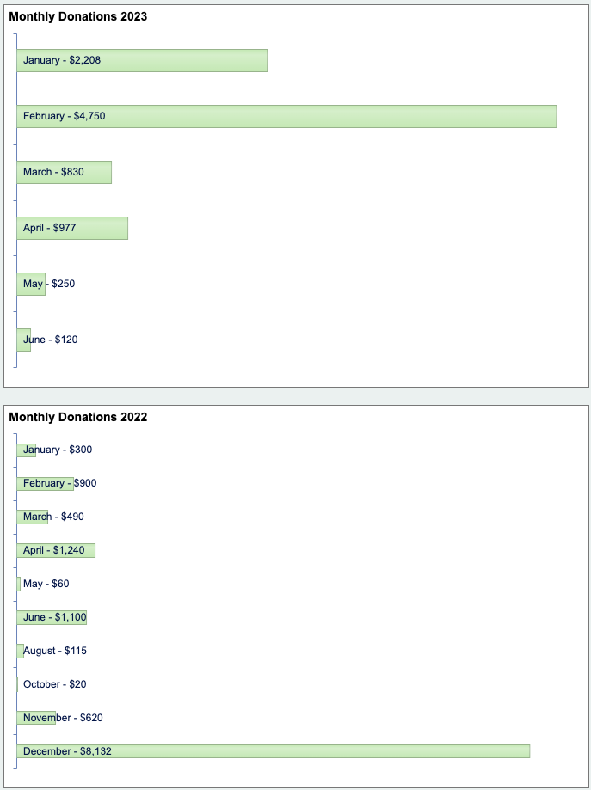
  - Vista poster
  - Merchandise simplification and new ordering (meeting before this board meeting on June 20 at 9am)

Reports
- Governance (Ginessa)
- Outreach (Debbie)
  - Alachua County Climate Fair
Notes from the Friends’ Booth at the Alachua County Climate Fair- Friday, June2, 2023 5:00 to 8:00PM
The Climate Fair was an outreach success. The weather was perfect. The venue was park-like. The 30 vendor booths had plenty of space and were set in a lovely, mowed- grass field, in a U-shape. Visitors could walk around the U or crisscross back and forth. There were also several food trucks. Attendance was hundreds, not thousands. We had about 50 come to the Friends’ booth. Many had never been to the Lower Suwannee NWR, although they’d been to Shell Mound and/or Cedar Key. Most were curious and wanted to know what to do and see. They were interested in the background and purpose of the Refuge, but also in the Refuge as a climate change mitigator for Alachua County. I expect some will come to the Summer Solstice event. We talked about it often and many were interested.
We sold a couple of butterfly shirts, 2 passport books, 1 butterfly book. Ginessa, Dan, Debbie, Russ, and Peg staffed the booth. Debbie brought the canopy and tables, white board and big poster, and other booth materials from the Refuge, and picked up hats from Bill. Peg picked up
shirts and butterfly guides from Barbara, and the tablecloth, Blue Goose passports and stamps, and a few other items from Jeri.
Alachua County Commissioners Anna Prizzia and Marihelen Wheeler each came by the booth. Anna wanted the whole visitor “talk” and seemed eager to come visit. Marihelen and her husband Paul spent quite a bit of time with us also. She was very interested in the Vista project. She thought the State would be interested in making something happen in
our region, and was impressed that Friends already had applied for and received two State grants. I mentioned that a few people had suggested we should invite Kat Camack to see Vista.
Marihelen said the person to invite is Kat’s deputy chief of staff/district director, Jessica Norfleet. Norfleet also worked for Yoho and according to Marihelen is the person behind some positive happenings on each of their watches. She gave us Norfleet’s # 352.354.5111.
She also suggested we check on Bill Schossler, who is CEO of his family’s foundation . . . The Henry and Rilla White Foundation. I looked up the foundation, which is local to our area. Its purpose is to provide “Developmental disability services”, so not a likely fit for Friends. Schossler’s address is Hodges Ave Cedar Key. He is not a Friends member.
Another booth visitor was Sam Johnson. He was working on a TikTok vlog, which he subsequently sent to us --
https://www.tiktok.com/@hiddenflorida/video/7240278422889581830
Submitted by Peg
June 3, 2023

  - The Solstice Celebration agenda is on our website and announced in the News Brief
  - The Cedar Key Junior Ranger summer program agenda is complete and is scheduled for June 26 and 27
  - Mobile Trailer bids
- Communications (Peg)
- Refuge Support (Scott) Ginessa for Scott
- Finances (Linda)
  - O’Brien grant application for mobile trailer

Open Discussion

Action Items

