Annual Meeting Minutes
Friends of Lower Suwannee & Cedar Keys NWRs
February 25, 2023

Participants: Approximately 140 members of Friends of Lower Suwannee & Cedar Keys NWRs, including officers and directors Ginessa Mahar, Denise Feiber, Peg Hall, Boyd Kimball, Linda Kimball, Dan Kline, John McPherson, Debbie Meeks, Paul Ramey, John Thalacker, Barbara Woodmansee, Bill Dummitt, Jeri Treat, Pete Tirrell, Scott Wright, Ron Kamzelski, Joe Hand.

The sun was shining. The no-see-ums were flocking. It was an almost perfect day for an outdoor event. Members signed-in and visited the welcome tables to chat about Friends Welcome Desk activities in Cedar Key and around the Refuge. The Junior Ranger program launched and several members picked up workbooks. The full report from Friends 2020 study of the historical, cultural, and architectural assessment of the Vista property captured a lot of attention with its almost 500 pages of photos, drawings, and stories. The new iGuide poster that shows all maps and brochures about the Lower Suwannee Refuge was on display.

The program started about 10:00. Friends’ President Debbie Meeks welcomed everyone, and gave an update on the Friends accomplishments of the past year.

Debbie presented the slate of officers and directors, whom the members elected.
Elected for a one-year term were:
- Ginessa Mahar, president
- Denise Feiber, president-elect
- Debbie Meeks, past president
Elected for a two-year term were:
- Bill Dummitt
- Peg Hall
- Debbie Jordan
- Dan Kline
- Ron Kamzelski
- John Thalacker
- Pete Tirrell
- Jeri Treat
- Scott Wright

Debbie then provided an overview of the Friends financial status.
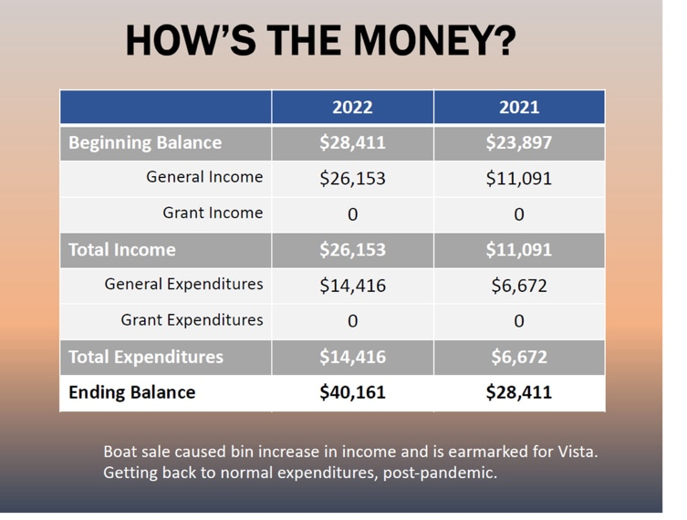

Refuge Manager Andrew Gude gave an update on the past year and Ginessa Mahar spoke about future Friends goals.

Dr. Ken Sulak's featured presentation was received with great interest and enthusiasm. He gave a detailed and personal look at the stories of Florida's early settlers, their triumphs and hardships.

At the end of the lunch, catered by Ken and Rose McCain, John Talalcker lead a River Trail walk with more than a dozen participants, and the doors of Vista were thrown open for docent guided tours.

Photos and presentations are available on Friends blog.

Submitted by Debbie Meeks
January 18, 2024

